

National University of Computer and Emerging Sciences



COGNIDRIVE NEXUS

**FYP Team**

Nimra Amer…………21L-5609

Muhammad Ahmad…………21L-5617

Muhammad Hamza…………21L-5636

Muhammad Hassan Khalid…………21L-5692

Ahmed Javed…………21L-7692

**FAST School of Computing**

**National University of Computer and Emerging Sciences**

**Lahore, Pakistan**

**11-2023**

Abstract

The “COGNIDRIVE NEXUS” project uses data science to calculate how much time(months) will be needed for the owner to fully own the car after the specific amount is deducted from his/her salary, monthly, depending on the cost of the car. This car ownership system is a scheme offered by the companies in which the company provides cars to its employees based on their designation. Our project aims to automate this process. The methodology we used includes both primary and secondary research by collecting data about employees, such as salary, provident funds, and car costs from different studies, research, and sources. Then, used a data science model to make predictions. The goal is to continually enhance the efficiency and accuracy of the process, enabling companies to manage employee benefits effectively and ensuring timely car ownership transfers that align with workforce changes.

Table of Contents

Table of Contents i

List of Tables iii

List of Figures iv

Chapter 1: Introduction 1

1.1 Purpose of this Document 1

1.2 Intended Audience 1

1.3 Definitions, Acronyms, and Abbreviations 1

Chapter 2: Project Vision 2

2.1 Problem Domain Overview 2

2.2 Problem Statement 2

2.3 Problem Elaboration 2

2.4 Goals and Objectives 2

2.5 Project Scope 2

2.6 Sustainable Development Goal (SDG) 2

2.7 Constraints 3

2.8 Business Opportunity 3

2.9 Stakeholders Description/ User Characteristics 3

2.9.1 Stakeholders Summary 3

2.9.2 Key High-Level Goals and Problems of Stakeholders 3

Chapter 3: Literature Review / Related Work 4

3.1 Definitions, Acronyms, and Abbreviations 4

3.2 Detailed Literature Review 4

3.2.1 Related Research Work 1 4

3.3 Literature Review Summary Table 4

3.4 Conclusion 4

Chapter 4: Software Requirement Specifications 5

4.1 List of Features 5

4.2 Functional Requirements 5

4.3 Quality Attributes 5

4.4 Non-Functional Requirements 5

4.5 Assumptions 5

4.6 Hardware and Software Requirements 5

4.6.1 Hardware Requirements 5

4.6.2 Software Requirements 5

4.7 Use Cases 5

4.7.1 Sample Use Case Name Here 5

4.8 Graphical User Interface 7

4.9 Database Design (*if required*) 7

4.9.1 ER Diagram 7

4.9.2 Data Dictionary 7

4.10 Risk Analysis 7

Chapter 5: Proposed Approach and Methodology 8

Chapter 6: High-Level and Low-Level Design 9

6.1 System Overview 9

6.2 Design Considerations 9

6.2.1 Assumptions and Dependencies 9

6.2.2 General Constraints 9

6.2.3 Goals and Guidelines 10

6.2.4 Development Methods 10

6.3 System Architecture 10

6.3.1 Subsystem Architecture 11

6.4 Architectural Strategies 11

6.4.1 Architectural Strategies Strategy-1 name or description 12

6.4.2 Architectural Strategies Strategy-2 name or description 12

6.5 Domain Model/Class Diagram 12

6.6 Sequence Diagrams 12

6.7 Policies and Tactics 12

6.7.1 Policy/tactic-1 name or description 13

6.7.2 Policy/tactic-2 name or description 13

Chapter 7: Implementation and Test Cases 14

7.1 Implementation 14

7.1.1 Implementation of First Component/Algorithm 14

7.2 Test case Design and description 14

7.2.1 Sample Test case No.1 14

7.3 Test Metrics 15

7.3.1 Sample Test case Matric.No.1 15

7.3.2 Sample Test case Metric.No.2 15

Chapter 8: User Manual 16

Chapter 9: Experimental Results and Discussion 17

Chapter 10: Conclusion and Future Work 18

References 19

Appendix 20

Appendix A: Guidelines 20

Appendix B: Heading of Sample Appendix B 20

Formatting Guidelines 21

Chapter 1: Heading 1 21

1.1 Heading 2 21

1.1.1 Heading 3 21

Tables and Figures 22

Equations 23

Header/Footer 23

Other Formatting Guidelines 23

References 23

List of Tables

Table 1: History of Computing Devices 4

Table 2: This is Sample table caption 22

Table 3: This is Sample table caption 22

List of Figures

Figure 1: Sustainable Development Goals 2

Figure 2: List of Styles 22

Figure 3: IEEE Reference style 23

# Introduction

## Purpose of this Document

The primary purpose of this document is to provide a comprehensive understanding of the project "Company Car Ownership Threshold Prediction." It aims to present the findings, research methodologies, and outcomes associated with the development of a predictive model for estimating the time required for an employee's monthly salary deductions to cover the cost of a company-provided car, leading to ownership transfer. The document serves as a reference for IT experts and employees involved in the project, offering insights into the rationale, methodologies, and results.

## Intended Audience

The intended audience for this document primarily includes IT experts and employees directly involved in or affected by the project. This may encompass individuals responsible for the development and implementation of the predictive model, as well as those utilizing the results for decision-making processes. Additionally, researchers seeking information or statistics related to this predictive modeling approach may find this document valuable. The document also contains a user manual, making it accessible to individuals who need guidance on using the implemented system.

## Definitions, Acronyms, and Abbreviations

List all important definitions, the acronyms and abbreviations used in this document.

**SDG:** Sustainable Development Goal

In conclusion, the "COGNIDRIVE NEXUS" project leverages data science to streamline the process of determining when an employee's monthly salary deductions will cover the cost of a company car, facilitating ownership transfer. The project encompasses a comprehensive vision, addressing the problem domain through extensive literature review, proposing a methodology involving data preprocessing, feature engineering, model selection, and continuous improvement. By providing a user-friendly interface and deploying a regression model, the system aims to enhance efficiency in managing company-provided cars and ensuring timely transfers, contributing to effective employee benefit administration. The report outlines the project's purpose, goals, and methodologies while guiding users through the application and presenting avenues for future enhancements.

# Project Vision

This chapter provides a focused introduction to the project's vision : determining when an employee's monthly salary deductions will meet the threshold for owning a company car. We aim to build a data science model for predicting the time required for car ownership eligibility. The chapter sets the stage for our goals, objectives, and the defined scope of the project.

## Problem Domain Overview

The model predicts the time it takes for an employee's monthly salary deductions to reach the threshold required for transferring the ownership of a company-provided car. The predictive model will consider various factors, including the employee's position, monthly salary, leaves, provident fund contributions, and other relevant variables, to provide a more accurate estimate.

## Problem Statement

The need for an accurate predictive model to estimate the time in months required for an employee's monthly salary deductions to cover the cost of a company car facilitating the timely and efficient transfer of car ownership to employees.

## Problem Elaboration

The project aims to figure out when an employee can own a company car based on their monthly salary deductions. The challenge is dealing with various details like job positions, monthly salaries, leaves, and other factors. We need to create a data science model that can adapt to changes over time, consider external factors, and understand how all these things work together. The goal is not just predicting but making smart decisions about when to transfer car ownership, keeping both employees and the company in mind.

## Goals and Objectives

Goals include the development of a machine learning model, handling time-series data, implementing data exploration, and deploying the model for making predictions on new employee data. Objectives focus on tasks like data collection, preprocessing, feature engineering, model training, and continuous improvement.

## Project Scope

The scope of the project encompasses historical employee data, positions, monthly salary, car cost, leaves, provident fund, ownership status etc. The predictive model will consider a comprehensive set of factors for accurate predictions.

This chapter sets the stage for the project, providing a clear understanding of the vision, goals, and objectives. It establishes the problem domain, outlines the specific challenges addressed, and defines the scope of the project. Subsequent chapters will delve into the technical details and implementation aspects of the project.

# Literature Review / Related Work

Predicting car ownership thresholds accurately is crucial in domains like financial planning and human resources management. Researchers have been exploring various methodologies to improve the precision of these predictions. This literature review aims to synthesize recent studies that use machine learning techniques and statistical metrics to enhance predictive accuracy for car ownership thresholds. It's exciting to see how these advancements can benefit different areas.

**Particle Swarm Optimization and Neural Networks:**

By integrating the Particle Swarm Optimization (PSO) algorithm with the Back Propagation (BP) neural network, Zhang et al. (2023) demonstrated how machine-learning techniques could significantly enhance the accuracy of car ownership predictions. Their study [1] highlights the potential of using economic indicators like gross national income and per capita GDP as input data. This exciting approach offers a promising avenue for developing precise models to determine when employee salary deductions reach the threshold for car ownership transfer.

**Time-Series Forecasting and Statistical Metrics:**

Kramar and Alchakov's research (2023) [2] focuses on time-series forecasting of seasonal data, specifically in predicting wastewater flow at a treatment plant. Their two-layer approach, which includes data preparation and model building, provides a structured framework for similar projects. By utilizing statistical metrics like MAE, MSE, and RMSE, they offer valuable insights into the broader applicability of predictive models. In the context of forecasting the time required for monthly salary deductions to cover the cost of a company-provided car, their methodologies and statistical metrics hold direct relevance. Their systematic approach serves as a practical guide for financial planning initiatives.

**Leveraging Big Data for Efficiency:**

The article "Leveraging Big Data Analytics for Intelligent Transportation Systems: Optimize the Internet of Vehicles Data Structure and Modeling" (2023) [3] highlights the significance of vehicle ownership in companies and the challenges posed by big data. The authors propose using big data analytics to improve efficiency and accuracy by analyzing information, similar to predicting the time when employees fully own a car. This approach not only streamlines systems but also leads to cost savings and time efficiency.

In summary, By leveraging advanced computer techniques, statistics, and large datasets, we can enhance our car ownership predictions. These methods offer valuable insights for decision-making in finance and human resources. Continued research will further refine these predictions, making them even more precise and useful. Let us keep exploring and advancing in this exciting field.

# Software Requirement Specifications

Describe all modules of requirements and design in clear English text along with the necessary diagram and figures. Anyone reading your report should be able to reproduce your system/results after reading it. It describes functional requirements, design constraints, and other factors necessary to provide a complete and comprehensive description of the requirements for the software.risks etc.

# Proposed Approach and Methodology

The proposed approach for predicting the time required for an employee's monthly salary deductions to cover the cost of a company-provided car is to develop a regression model that accurately estimates the number of months it takes for an employee to reach the car ownership threshold. The methodology encompasses various stages, including data preprocessing, feature engineering, model selection, training, and evaluation.

**Data Preprocessing**

In the data preprocessing phase, the historical employee data is cleaned and transformed to be fed into the model. This includes handling missing values, addressing outliers, and normalizing relevant variables to maintain consistency in the dataset. Furthermore, to capture temporal patterns and trends, time-series data of monthly salaries and car expenses are subjected to particular processing.

**Feature Engineering**

Feature engineering plays a pivotal role in enhancing the predictive capabilities of the model. Various features are calculated, such as monthly salary deductions, cumulative deductions, and the current status of car ownership. Additionally, the algorithm considers factors like leaves, provident fund contributions, promotions, and other financial variables to capture a comprehensive view of the employee's financial situation.

**Model Selection**

The chosen machine learning model for predicting the time required for an employee's monthly salary deductions to cover the cost of a company-provided car is a regression model. Regression models are particularly suitable for tasks where the objective is to predict a continuous numerical outcome, as in our case. This decision is made to ensure the model captures the relationships between input features, such as salary, leaves, provident fund contributions, and the target variable—the time in months needed to reach the car ownership threshold.

**Model Training**

With the regression model selected, the dataset is split into training and testing sets. During the training phase, the regression model is refined by optimizing its parameters to achieve the best fit for our specific prediction task. Evaluation metrics like Mean Absolute Error (MAE), Mean Squared Error (MSE), and Root Mean Squared Error (RMSE) are used to assess the performance of the regression model.

**Deployment**

The regression model, having demonstrated satisfactory performance on the testing set, is ready for deployment. Integrated into the company's existing systems, the regression model automates the prediction process, providing real-time estimates as new employee data becomes available. This deployment enhances operational efficiency and facilitates timely decision-making regarding car ownership transfer.

**Continuous Improvement**

Ensuring the ongoing accuracy and relevance of our regression model is a priority. We implement a continuous improvement strategy that involves periodic retraining with new data. This allows the model to adapt to changes in company policies or employee dynamics. Additional features or refinements are incorporated during these iterations, ensuring the regression model remains a valuable and up-to-date tool for decision-making over time.

In conclusion, the regression model emerges as the optimal choice for our project, enabling accurate predictions regarding the time required for an employee's salary deductions to cover the cost of a company-provided car. This approach, encompassing data preprocessing, feature engineering, regression model training, deployment, and continuous improvement, positions our solution to be robust, adaptable, and valuable for companies seeking to streamline the management of company-provided cars and enhance employee satisfaction.

# High-Level and Low-Level Design

Provide the high- and low-level design of your system in this chapter. Select the design that is appropriate for your project.



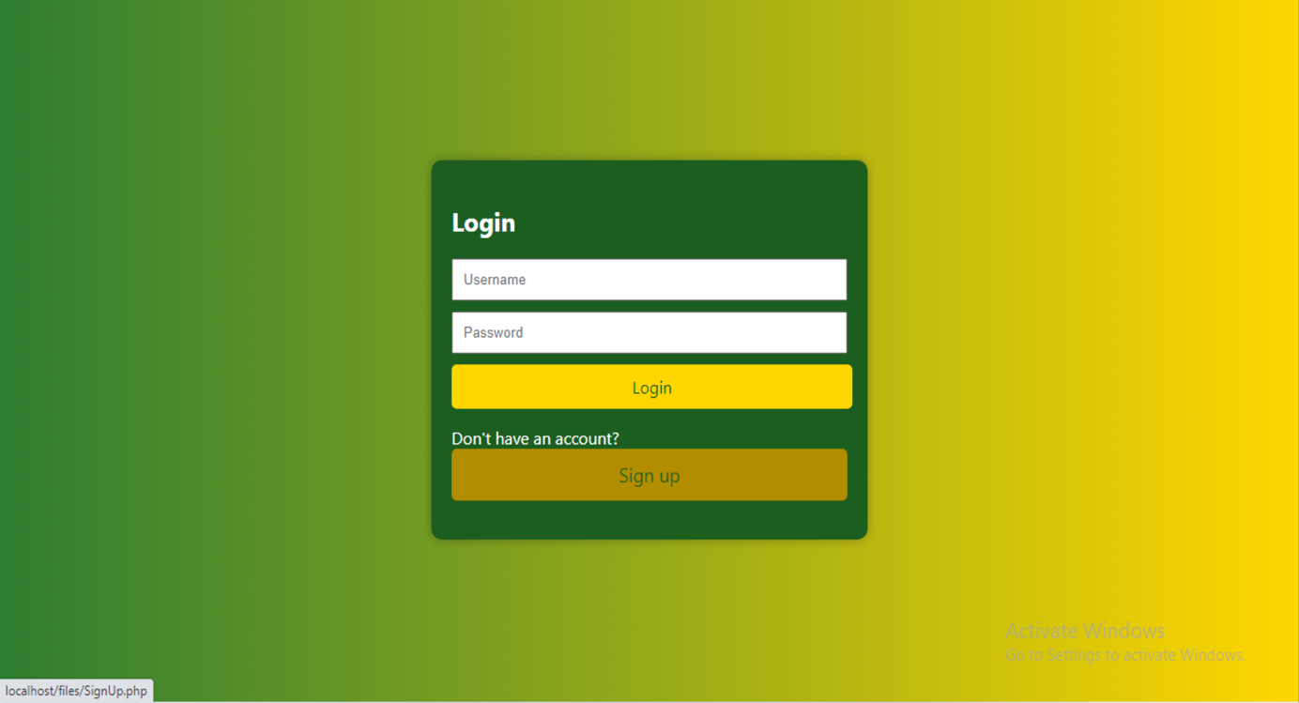

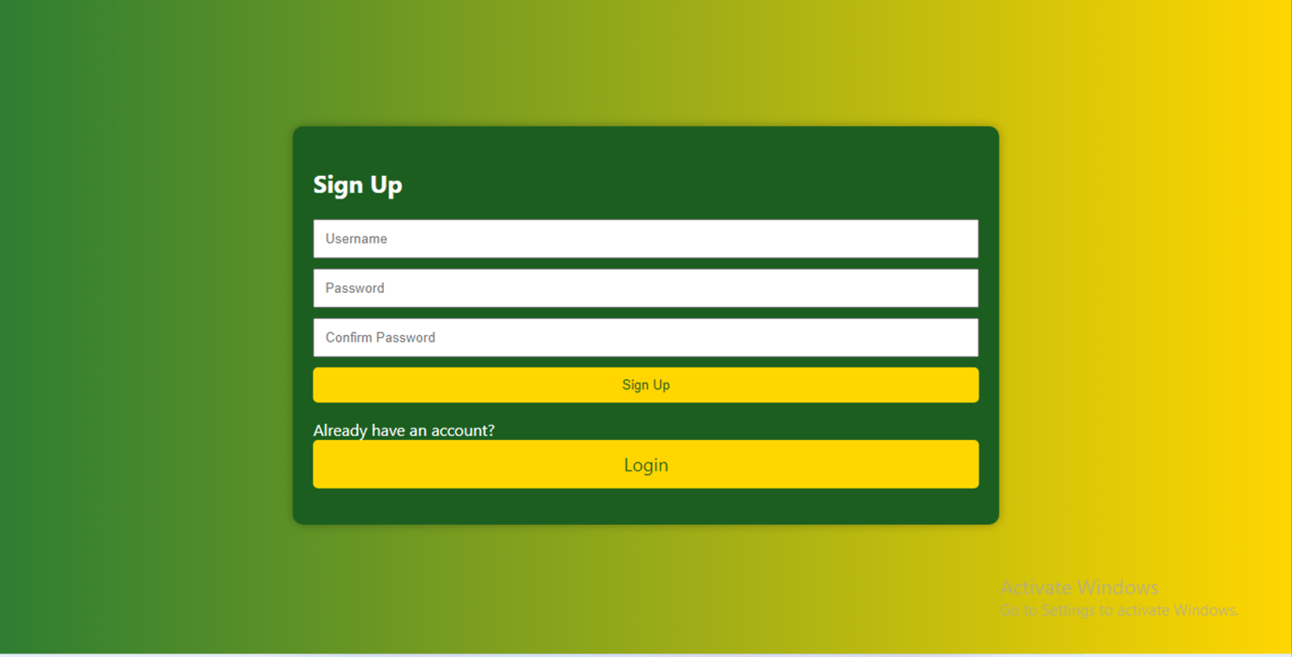

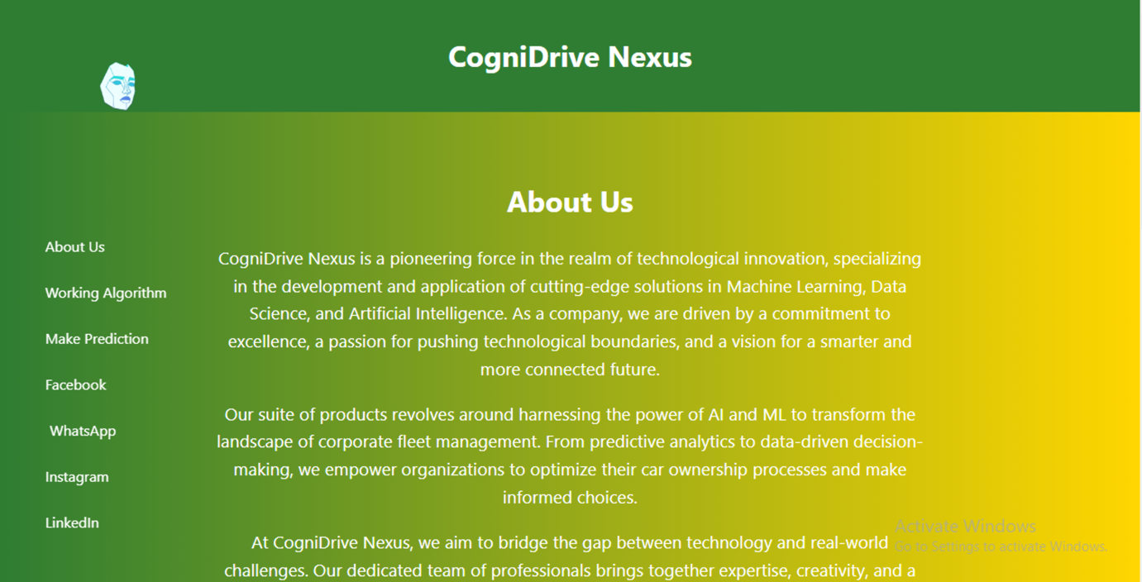

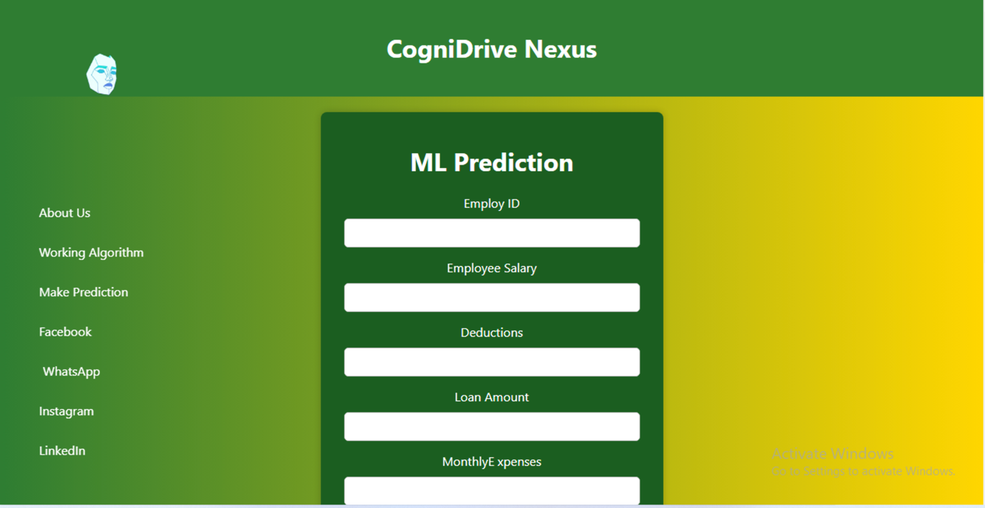

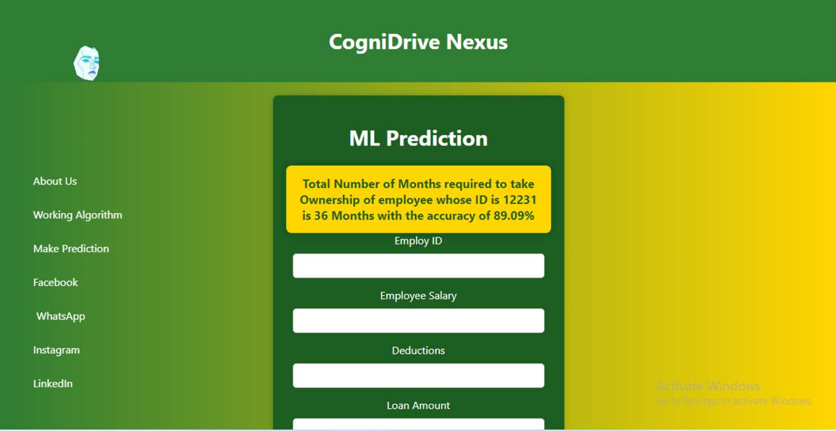

# Implementation and Test Cases

**For each chapter provide a paragraph of introduction and in the end a paragraph of conclusions.** (Not the programming code but the algorithmic and procedural details especially related to the hidden/ backend algorithms that are not covered in the design)

# User Manual

Welcome to COGNIDRIVE NEXUS – Your Intelligent Car Ownership Predictor. This system is designed to provide accurate predictions regarding the time it takes for an employee's monthly salary deductions to cover the cost of a company car, making the car eligible for ownership transfer. This chapter provides guidance on using the system effectively.

**Getting Started**

To begin using COGNIDRIVE NEXUS, follow these initial steps:

**1. Loading Page:**

Upon accessing the application, you will first encounter the loading page. This indicates that the application is initializing. Please wait patiently for the process to complete.

**2. Login:**

If you are an existing user, click on the "Login" button. Enter your credentials (username and password) to access your account and personalized features.

**3. Signup:**

New users can click on the "Signup" button to create an account. Fill in the required information, choose a secure password, and click on "Signup" to create your account.

**4. Dashboard:**

Once logged in, you will be directed to your personalized dashboard. Here, you can find relevant information about your account and previous predictions.

**5. Navigation Bar:**

The navigation bar provides quick access to various sections of the application, including:

* Home
* Contact Us
* About Us
* Logout

**6. Contact Us:**

Feel free to reach out to us through the "Contact Us" section. You can connect with us on social media platforms like Instagram and Facebook using the provided buttons.

**7. About Us:**

Learn more about the application and the development team in the "About Us" section.

**8. User Guidelines:**

For a better understanding of the application, refer to the "User Guidelines" section. It provides helpful tips and recommendations.

**9. Start a Prediction:**

To initiate a new prediction, click on the "Start a Prediction" button.

**10. Enter Required Values:**

A new page will open, prompting you to enter the necessary information. Input employee-related data, such as position, monthly salary, car cost, etc. Ensure that all fields are filled accurately.

**11. Click Predict Button:**

After entering the required values, click on the "Predict" button to submit your data for analysis.

**12. View Result:**

The prediction results will be displayed on the screen. You can view the estimated time in months required for the employee's salary deductions to cover the cost of the company car, making it eligible for ownership transfer.

Congratulations! You have successfully used the Company Car Ownership Threshold Prediction Application. For any further assistance, feel free to refer to the "Contact Us" section or consult the provided user guidelines. Thank you for choosing our application!

# Conclusion and Future Work

## Conclusion:

The "COGNIDRIVE NEXUS" project, centered around using data science to predict the time required for an employee's monthly salary deductions to cover the cost of a company car, has reached a significant milestone. Through the integration of machine learning techniques, data preprocessing, and continuous improvement strategies, our predictive model offers a valuable solution for automating the car ownership transfer process.

The journey began with a clear understanding of the problem domain, emphasizing the need for precision in estimating the time it takes for salary deductions to reach the car ownership threshold. The literature review provided insights into existing methodologies, including the integration of Particle Swarm Optimization and Neural Networks, time-series forecasting, and leveraging big data for efficiency. These insights informed our approach and methodology, leading to the development of a regression model.

The proposed approach involved meticulous data preprocessing, feature engineering, and model selection. The regression model, trained on historical employee data, demonstrated its efficacy in accurately predicting the number of months required for ownership transfer. With a focus on user experience, the user manual was crafted to guide individuals through the application, ensuring a seamless and informative interaction.

**9.2 Future Work:**

While the project has achieved its primary objectives, there are avenues for future work and improvement:

1. Enhanced Features: Explore the incorporation of additional features into the predictive model to further refine accuracy. Factors such as employee performance metrics, promotions, or changes in company policies could contribute to a more comprehensive prediction.
2. Real-time Data Integration: Move towards a more dynamic system by integrating real-time data sources. This could involve connecting directly to payroll systems and employee databases to provide up-to-the-minute predictions.
3. User Feedback Implementation: Gather user feedback on the application's usability and accuracy. Implement any suggested improvements to enhance the user experience and ensure the model remains aligned with the evolving needs of the organization.
4. Exploration of Advanced Algorithms: Investigate the potential of advanced machine learning algorithms beyond regression models. Techniques such as deep learning or ensemble methods may offer further improvements in predictive capabilities.
5. Expanded Scope: Consider expanding the scope of the predictive model to cover a broader range of employee benefits or financial planning aspects. This could provide a holistic solution for organizations looking to optimize various aspects of employee compensation.

In conclusion, "COGNIDRIVE NEXUS" marks a significant step forward in automating and optimizing the process of predicting car ownership eligibility. The continuous pursuit of innovation and refinement will ensure the model remains a valuable tool for companies seeking efficient management of company-provided cars and enhanced employee satisfaction.

# References

[1] Y. Zhang, Y. Li, and Y. Zhang, "Prediction Model of Car Ownership Based on Back Propagation Neural Network Optimized by Particle Swarm Optimization", Available: <https://www.mdpi.com/2071-1050/15/4/2908>, Feb.6, 2023 [Oct. 28, 2023].

[2] J. Kramar and A. Alchakov, "Time-Series Forecasting of Seasonal Data Using Machine Learning Methods", Available: <https://www.mdpi.com/1999-4893/16/5/248>, May.10, 2023 [Oct. 28, 2023].

[3] Gebeyehu Belay Gebremeskel, “Leveraging Big Data Analytics for Intelligent Transportation Systems: Optimize the Internet of Vehicles Data Structure and Modeling”, Available: <https://www.researchsquare.com/article/rs-1640856/v2>, Jan.03, 2023 [Oct. 28, 2023].

# Appendix

## Appendix A: Guidelines

This section should include all supporting information from the project that was not included in the body of the report.  You should include surveys, complex statistical calculations, certain detailed tables and other such information in an appendix.  The information presented in this section is important to support the work presented in the body of the report but would make it more difficult to read and understand if presented within the body of the report.

Cite the appendix items in the report narrative (write "see Appendix A") and organize appendices (e.g., Appendix A, Appendix B,

Any tables, figures, forms, or other materials that are not totally central to the analysis but that need to be included are placed in the Appendix.

## Appendix B: Heading of Sample Appendix B

Following is a sample code with “code” style format.

Void SampleFunction(){

Print “Hello World.”;

}

# Formatting Guidelines

This document also serves as style guide for final year project reports. In order to give a similar high-quality appearance to all final year software project reports this template uses a collection of predefined Microsoft Word formatting styles. **These styles should be used without modification or replacement.** Font in the document is ***“Time New Roman”.*** This template provides following styles:

* **Title** – the main title style
* **Title2** – the subtitle style
* **Body Text** – style for paragraphs
* **Caption** – the style for a figure or table caption
* **Table Description** – the style for description of table, it must be added after caption.
* **Figure Description** - the style for description of figure, it must be added after caption.
* **Code** – the style for program source code
* **int x** = 10; // Writing important code
* **Table Header Row** – Style for the header row of table
* **Table Grid** – the style for the data rows in the tables
* **Reference** – The style for references
* **Bullets** – The style for the bullet lists
* **Numbered** **List**– Style for numbered lists

All Heading styles with different level numbers are listed below.

# Heading 1

## Heading 2

### Heading 3

#### Heading 4

##### Heading 5

###### Heading 6

Heading 7

Heading 8

Heading 9

## Tables and Figures

Tables and figures should be centered horizontally. The caption button should be used to insert caption for both the figures and tables. All figures and tables must be numbered properly. Always refer to tables and figures according to their numbers. A table or figure can be cited as follows: ‘see Table1’ or ‘as shown in Table1’. The caption of table should be centered above the table and figure caption should be centered below the figure. Place the tables/figures close to their reference. Use “Table Header Row” and ‘Table Grid’ style for table’s header and data rows respectively. It is compulsory to provide brief description of table/figure after its caption. Styles for table and figure descriptions are “Table Description” and “Figure Description” respectively.

Press **Ctrl + Shift + S** to see list of styles mentioned above. Figure 1 shows the Apply Style window displaying the list of styles. Select any text then press **Ctrl + Shift + S**, the Apply Style window will show you the current style applied on that text and if required, you can change the style by selecting any other style from the “Style Name” dropdown.

This is brief description of above figure.

Figure 2: List of Styles

Table 2: This is Sample table caption

This is brief description of following Table.

|  |  |  |  |
| --- | --- | --- | --- |
| Header row | Header row | Header row | Header row |
| Row1 col1 | Row1 col2 | Row1 col3 | Row1 col4 |
| Row2 col1 | Row2 col2 | Row2 col3 | Row2 col4 |

Table 3: This is Sample table caption

This is brief description of following Table.

|  |  |  |  |
| --- | --- | --- | --- |
| Header row | Header row | Header row | Header row |
| Row1 col1 | Row1 col2 | Row1 col3 | Row1 col4 |
| Row2 col1 | Row2 col2 | Row2 col3 | Row2 col4 |

## Equations

Use equation editor to write equations in this report. Use last button of the custom tool bar to invoke equation editor. Similar to tables and figures, equations should also be aligned centered horizontally. Number all equations and insert them in parenthesis. Below is a sample equation and its reference number. An equation can be referenced like this: ‘it is clear from (1)’.

 (1)

## Header/Footer

Notice the headers in this document, before Introduction (i.e., the main content of this document) page numbers are in roman numerals. The page numbers of the actual content start with Arabic numerals i.e. 1, 2, 3 and so on. All of the **odd numbered pages** contain title of your project while the **even numbered pages** contain the section heading (i.e., chapter’s name) in the headers.

## Other Formatting Guidelines

* Keep 2-4 GUIs in one page. Consume as much space as possible. Do not leave most of page blank unnecessarily.
* Do not break tables (or use cases) in multiple pages unless the table is too large to fit in one page.
* Re-arrange the content i.e., text, images and tables properly to meet above two guidelines.

## References

Always refer to the source of information by inserting the reference number in square brackets like this [5]. The reference numbers can either be added at the end of the sentence or within the sentence without changing the punctuation of sentence. A reference can also be cited as follows: ‘as Ruskey [2] mentioned’. List each source only once on your reference page.

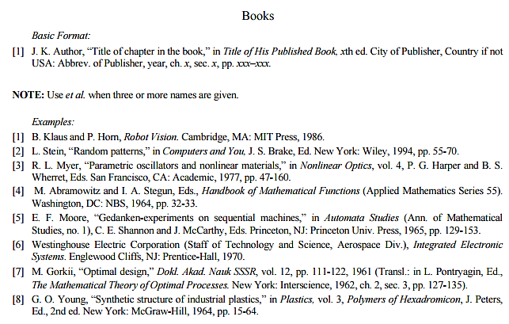

Figure 3: IEEE Reference style

This figure represents the styling information for adding references in IEEE format

**Following is a list of sample reference for various type of sources in IEEE format.**

1. P.M. Morse and H. Feshback, *Methods* of *Theoretical Physics*. New York: McGraw Hill, 1953. **//Format for Book**
2. S.K. Kenue and J.F. Greenleaf, “Limited angle multifrequency deification tomography,” *IEEE Trans. Sonics Ultrason*., vol. SU-29, no. 6, pp. 213-2 17, July 1982. **//Format for Journal Article**
3. B. Tsikos, “Segmentation of 3-D scenes using multi-modal interaction between machine vision and programmable mechanical scene manipulation,” Ph.D. dissertation, Univ. of Pennsylvania, BCE Dept., Philadelphia, 1987. [Add if applicable: University Microfilms, Inc., University of Michigan, Ann Arbor, Michigan.] **//Format for Dissertation or thesis**
4. R. Finkel, R. Taylor, R. Bolles, R. Paul, and J. Feldman, “An overview of AL, programming system for automation,” in *Proc. Fourth Int. Joint Conf Artif. Intell*., pp. 758-765, Sept. 3-7, 1975. **//Format for Proceedings paper**
5. “Technology threatens to shatter the world of college textbooks, *The Wall Street Journal*, vol 91, pp. Al, A8, June 1, 1993. **//Format for Newspaper article**
6. R. Cox and J. S. Turner, “Project Zeus: design of a broadband network and its application on a university campus,” Washington Univ., Dept. of Comp. Sci., Technical Report WUCS-91-45, July 30, 1991. **//Format for Technical Report**
7. M. Janzen, *Instant Access Accounting*. Computer software. Nexus Software, Inc IBM-PC, 1993. **//Format for** **Software**
8. Fuminao Okumura and Hajime Takagi, “Maglev Guideway On the Yamanashi Test Line,” *http://www.rtri.or.jp/rd/maglev2/okumura.html*, October 24, 1998. **//Format for** **World Wide Web** (give author and title if named)
9. “AT&T Supplies First CDMA Cellular System in Indonesia,” http://www.att.com/press/1095/951011.nsa.html, Feb 5, 1996. **//Format for World Wide Web**